

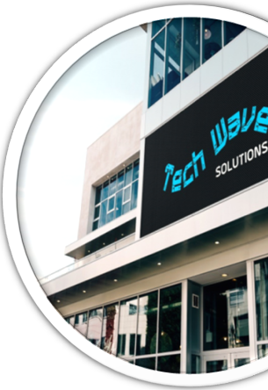

**Report on**

**Performance Analysis of Tech Wave Solutions**

**Submitted By:** Mehjabin Zaman

**Batch Number:** 21

**Date** : 06/10/2024

Index

1 Executive Summery 2

2 Products and Services 3

2.1 Laptops 3

2.1.1 Product Line: 3

2.1.2 Key Features: 4

2.2 Smartphones 4

2.2.1 Product Line: 4

2.2.2 Key Features: 4

2.3 Tablets and Smart Accessories 4

2.3.1 Product Line: 5

2.3.2 Key Features: 5

3 Product Range Breakdown 5

4 Business Plan 6

4.1 Operations: 7

4.2 Timeline: 7

4.3 Competitor Analysis: 7

4.4 SWOT Analysis: 7

*4.4.1* *Strengths:* 7

*4.4.2* *Weaknesses:* 8

*4.4.3* *Opportunities:* 8

*4.4.4* *Threats:* 8

4.5 Mission Statement: 8

4.6 Marketing Plan: 8

4.7 Product Features: 9

4.8 Financial Planning: 9

5 Sales and Cost Statistics 10

5.1 Table 10

5.2 Charts 11

# Executive Summery

TechWave Solutions is a forward-thinking technology company that specializes in providing high-quality electronic devices such as laptops, smartphones, tablets, and smart accessories. Since its inception in 2020, TechWave has grown rapidly, serving both individual consumers and businesses. Our mission is to offer innovative, durable, and eco-friendly tech products that meet the evolving needs of the digital world. Through a combination of superior technology and excellent customer service, we are committed to enhancing the digital experiences of our customers.

TechWave Solutions is an innovative technology company headquartered in Silicon Valley, California. Our primary focus is on designing and delivering high-performance electronic devices, including laptops, smartphones, tablets, and various smart accessories. TechWave was established with the vision of creating cutting-edge technology products that bridge the gap between performance, style, and sustainability. Our products are crafted to meet the demands of modern consumers, from individual users looking for the latest in mobile technology to businesses seeking reliable, scalable tech solutions. Since our inception, we have rapidly gained a reputation for delivering products that combine sleek design with advanced functionality. Our laptops and smartphones are equipped with state-of-the-art processors, long battery life, and superior build quality, providing customers with high performance and longevity. Additionally, we offer a range of accessories, from wireless earbuds and smartwatches to eco-friendly portable chargers, catering to the needs of tech-savvy individuals and professionals alike.

Market Position & Growth TechWave has consistently stayed ahead of market trends, driving innovation in the consumer electronics space. We operate in a highly competitive market but differentiate ourselves by emphasizing quality, innovation, and customer-centric solutions. Our commitment to research and development has allowed us to launch new, cutting-edge products each year, catering to a diverse global customer base. Despite being a relatively young company, TechWave has achieved substantial growth through strategic partnerships, expanding our distribution channels, and launching a highly successful e-commerce platform. Our direct-to-consumer sales model has enabled us to reach customers worldwide, while our strong presence in major retail chains ensures high visibility across various regions. Sustainability & Social

Responsibility As a tech company of the future, we are committed to sustainability. Our devices are made using eco-friendly materials, and we are actively reducing our carbon footprint through energy-efficient manufacturing processes. Additionally, we invest in community-based initiatives that support digital education and empower underprivileged communities with access to technology.

This expanded version covers more aspects of TechWave’s vision, market position, and future plans. It positions the company as a leader in innovation, growth, and sustainability.

# Products and Services

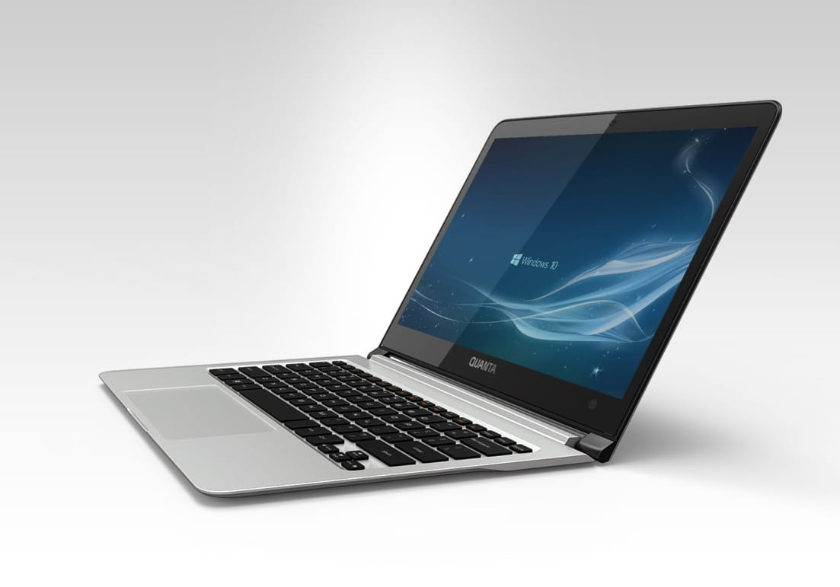TechWave Solutions offers a diverse range of high-quality electronic devices designed to meet the needs of both individual consumers and businesses. Our products are crafted with advanced technology and an emphasis on performance, reliability, and sustainability. Below are the key product categories we specialize in:

## Laptops

Our laptops are engineered to deliver exceptional performance for a variety of uses, from casual browsing and entertainment to heavy professional workloads like software development, graphic design, and gaming.

### Product Line:

***TechWave Zenith:*** A premium line of ultra-thin, high-performance laptops designed for professionals and creators.

***TechWave Pulse:*** Affordable yet powerful laptops ideal for students, home users, and small businesses.

### Key Features:

* Latest-generation processors (Intel and AMD)
* Lightweight, durable designs with extended battery life
* High-resolution displays with superior color accuracy

## Smartphones

Our smartphones integrate cutting-edge technology with sleek designs, making them the perfect companion for users who demand the best in mobile performance and aesthetics.

### **Product Line**:

***TechWave XPro:*** A flagship smartphone with a powerful camera, AI-driven performance, and 5G connectivity.

***TechWave Fusion:*** A mid-range smartphone offering premium features at an affordable price, ideal for budget-conscious consumers.

### Key Features:

* High-resolution multi-lens cameras with AI-enhanced photography
* 5G network compatibility for faster downloads and smoother streaming
* Advanced biometric security (facial recognition, fingerprint sensors)

## Tablets and Smart Accessories

Our tablets provide the perfect blend of power and portability, suitable for both personal use and business applications. We also offer a wide range of smart accessories designed to enhance user experiences with our devices.

***TechWave Tab:*** Lightweight and versatile tablets perfect for multimedia consumption, note-taking, and creative projects.

### Product Line:

***TechWave Smart Accessories:*** Includes wireless earbuds, smartwatches, Bluetooth speakers, and eco-friendly portable chargers.

### Key Features:

* Multi-touch screens and stylus support for creative professionals
* Long battery life and fast charging technology
* Bluetooth 5.0 and wireless compatibility with all major platforms

For more details, visit our [website](https://techwave.net/).

# Product Range Breakdown

To better visualize our range of products, we categorize them into three primary segments:

# Business Plan

.Our plan is divided into key stages that ensure product development, customer acquisition, and overall business scalability aligned with our long-term vision. The following flowchart illustrates the stages of our business plan:

**Timeline**

**Business**

**Plan**

**Marketing Plan**

**SWOT Analysis**

**Competitor Analysis**

**Operations**

**Financial Planning**

**Mission Statement**

**Product Description**

## Operations:

* TechWave’s operations will focus on software development, customer support, and continuous innovation in AI-driven products. This includes:
* Development teams working on core software and cloud infrastructure.
* Customer support teams providing 24/7 assistance to global clients.
* A research and development (R&D) team dedicated to future products.
* Use of agile methodologies to quickly respond to market needs and client feedback.

## Timeline:

Year 1-2: Develop and launch core AI-driven business management software.

Year 3: Expand into the cloud computing sector by offering scalable solutions.

Year 4: Penetrate international markets in North America and Europe.

Year 5: Introduce integrated AI platforms tailored for specific industries (e.g., healthcare, finance).

## Competitor Analysis:

TechWave faces competition from established tech companies like Microsoft Azure, Salesforce, and Google Cloud. Competitor analysis includes, Large market share, brand reputation, and comprehensive service offerings, Slower to innovate, higher cost, complex integrations. TechWave can differentiate itself by offering affordable, more user-friendly, and highly customizable solutions tailored to mid-sized businesses and industries with specific needs.

## SWOT Analysis:

### *Strengths:*

* Innovative AI-driven software with user-friendly features.
* Ability to quickly adapt and develop new tools due to its smaller size and agile development approach.

### *Weaknesses:*

* Limited brand recognition compared to larger, established tech companies.
* Smaller sales force and fewer global resources.

### *Opportunities:*

* Growing demand for AI and cloud solutions as businesses increasingly digitize.
* Expansion into emerging markets where competition is lower.

### *Threats:*

* Intense competition from larger tech companies.
* Rapid changes in technology and potential regulatory challenges in data management.

## **Mission Statement**:

***TechWave’s Mission:*** "To empower businesses with cutting-edge AI solutions and scalable cloud technology that transforms the way they operate and grow, while ensuring simplicity, reliability, and security in every product."

## Marketing Plan:

TechWave’s marketing strategy will focus on a B2B (business-to-business) approach. Key elements include:

***Target Audience:*** Small to mid-sized companies needing enterprise resource planning (ERP), AI-powered analytics, and cloud solutions.

***Digital Marketing:*** Online campaigns targeting decision-makers on platforms like LinkedIn and through content marketing (blogs, webinars, etc.).

***Partnerships:*** Strategic alliances with consulting firms, resellers, and cloud infrastructure providers.

***Branding:*** Position TechWave as a customer-centric, innovative, and cost-effective alternative to larger providers.

***Core Product:*** TechWave offers AI-powered enterprise software that integrates cloud computing, data analytics, and automation.

## Product Features:

* AI-based automation for business processes like inventory management, sales forecasting, and customer service.
* Scalable cloud services for businesses that need flexibility.
* Customizable data analytics dashboards that allow businesses to track and predict key performance metrics.

## Financial Planning:

***Initial investment***: $2 million in development and marketing in Year 1.

***Revenue Projections***: $5 million by the end of Year 3 from software subscriptions, cloud services, and custom AI solutions.

***Funding Requirements*** An additional $3 million in external investment to scale operations globally by Year 3.

***Break-even Point:*** Expected in Year 4, as recurring subscription revenues from the SaaS (Software as a Service) model will cover operating expenses.

# Sales and Cost Statistics

## Table

Yearly report of the company

**Yearly report**

|  |  |  |  |
| --- | --- | --- | --- |
| **Month** | **Expenses** | **Sales** | **Profit** |
| January | 9288500 | 8750000 | -538500 |
| February | 9744300 | 9920000 | 175700 |
| March | 8904700 | 10000000 | 1095300 |
| April | 7345200 | 7957400 | 612200 |
| May | 8987000 | 9876500 | 889500 |
| June | 5215400 | 5164500 | -50900 |
| July | 9976500 | 11543600 | 1567100 |
| August | 7976700 | 8087900 | 111200 |
| September | 9879000 | 9969800 | 90800 |
| October | 6234800 | 7024000 | 789200 |
| November | 4534800 | 4809300 | 274500 |
| December | 8348700 | 8834800 | 486100 |

The table shows a company's yearly report, detailing monthly expenses, sales, and profit from January to December. Some months show losses (e.g., January and June), while others have positive profits, with July having the highest profit at 1,567,100. The data compares expenses against sales to calculate monthly profit or loss.

## Charts

There are some chart showing sales, cost and profit for the year of the company given below:

The chart is a bar graph showing the company's monthly sales, expenses, and profit for the year. The x-axis represents the amount, while the y-axis lists the months from January to December. The chart uses three color-coded bars for each month: red for sales, blue for expenses, and green for profit. The graph visually compares these figures, showing months with positive and negative profits.

***Profit Margin Chart***